**The Elements of Value**

* [Eric Almquist](https://hbr.org/search?term=eric+almquist)
* [John Senior](https://hbr.org/search?term=john+senior)
* [Nicolas Bloch](https://hbr.org/search?term=nicolas+bloch)

FROM THE SEPTEMBER 2016 ISSUE

* [SUMMARY](https://hbr.org/2016/09/the-elements-of-value?utm_campaign=HBR&utm_source=facebook&utm_medium=social#article-top)

* [SAVE](https://hbr.org/2016/09/the-elements-of-value?utm_campaign=HBR&utm_source=facebook&utm_medium=social)

* [SHARE](https://hbr.org/2016/09/the-elements-of-value?utm_campaign=HBR&utm_source=facebook&utm_medium=social)

* [COMMENT](https://hbr.org/2016/09/the-elements-of-value?cm_sp=Article-_-Links-_-Comment#comment-section)

* [TEXT SIZE](https://hbr.org/2016/09/the-elements-of-value?cm_sp=Article-_-Links-_-Text%20Size)

* [PRINT](javascript:window.print();)

* [**8.95**  
  BUY COPIES](https://hbr.org/product/the-elements-of-value/R1609C-PDF-ENG?cm_sp=Article-_-Links-_-Buy%20PDF)

The Elements of Value

**VIEW MORE FROM THE**

[**September 2016 Issue**](https://hbr.org/archive-toc/BR1609?cm_sp=Article-_-Links-_-Magazine%20Issue)

[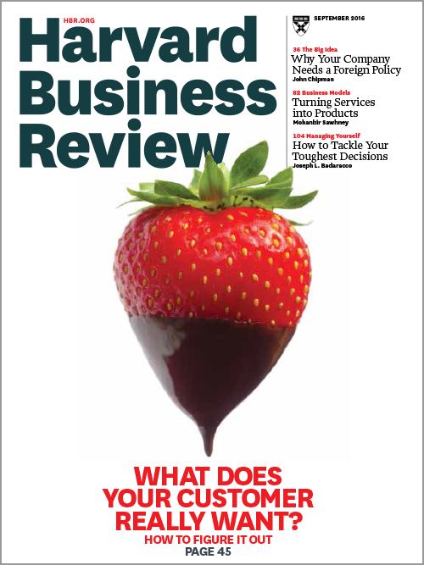](https://hbr.org/archive-toc/BR1609?cm_sp=Article-_-Links-_-Magazine%20Issue)

[**EXPLORE THE ARCHIVE**](https://hbr.org/magazine?cm_sp=Article-_-Links-_-Magazine%20Issue)

When customers evaluate a product or service, they weigh its perceived value against the asking price. Marketers have generally focused much of their time and energy on managing the price side of that equation, since raising prices can immediately boost profits. But that’s the easy part: Pricing usually consists of managing a relatively small set of numbers, and pricing analytics and tactics are highly evolved.

What consumers truly value, however, can be difficult to pin down and psychologically complicated. How can leadership teams actively manage value or devise ways to deliver more of it, whether functional (saving time, reducing cost) or emotional (reducing anxiety, providing entertainment)? Discrete choice analysis—which simulates demand for different combinations of product features, pricing, and other components—and similar research techniques are powerful and useful tools, but they are designed to test consumer reactions to preconceived concepts of value—the concepts that managers are accustomed to judging. Coming up with new concepts requires anticipating what else people might consider valuable.

The amount and nature of value in a particular product or service always lie in the eye of the beholder, of course. Yet universal building blocks of value do exist, creating opportunities for companies to improve their performance in current markets or break into new ones. A rigorous model of consumer value allows a company to come up with new combinations of value that its products and services could deliver. The right combinations, our analysis shows, pay off in stronger customer loyalty, greater consumer willingness to try a particular brand, and sustained revenue growth.

We have identified 30 “elements of value”—fundamental attributes in their most essential and discrete forms. These elements fall into four categories: functional, emotional, life changing, and social impact. Some elements are more inwardly focused, primarily addressing consumers’ personal needs. For example, the life-changing element *motivation* is at the core of Fitbit’s exercise-tracking products. Others are outwardly focused, helping customers interact in or navigate the external world. The functional element*organizes* is central to The Container Store and Intuit’s TurboTax, because both help consumers deal with complexities in their world.

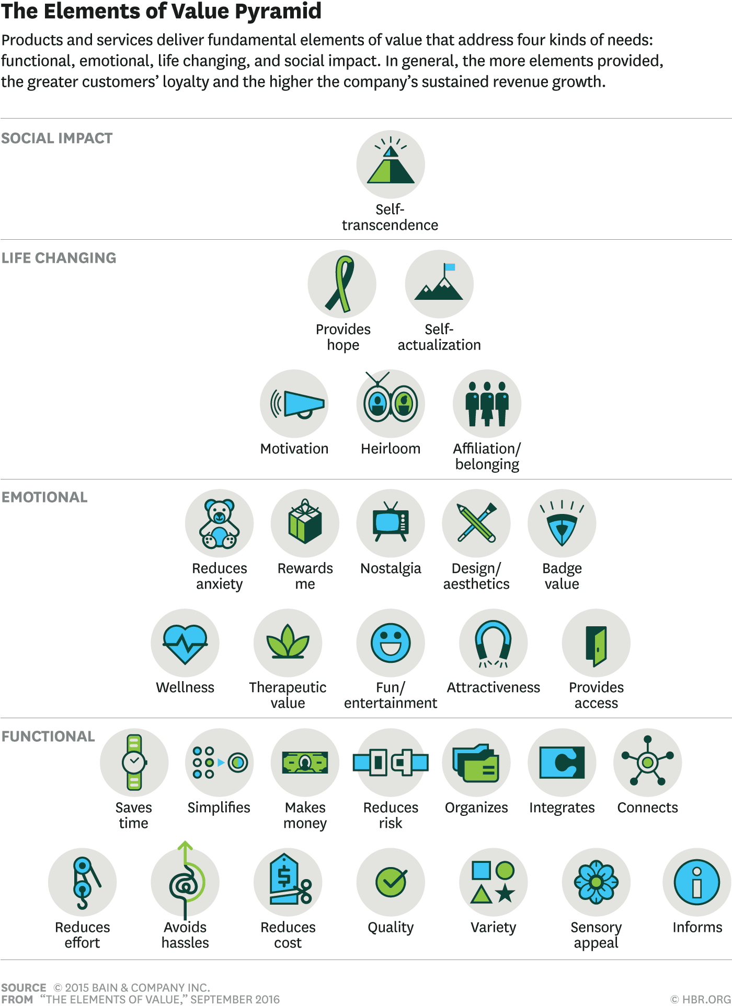

ICONS BY NIK SCHULZ

In our research we don’t accept on its face a consumer’s statement that a certain product attribute is important; instead we explore what underlies that statement. For example, when someone says her bank is “convenient,” its value derives from some combination of the functional elements *saves time,* *avoids hassle,simplifies,* and *reduces effort.* And when the owner of a $10,000 Leica talks about the quality of the product and the pictures it takes, an underlying life-changing element is *self-actualization,* arising from the pride of owning a camera that famous photographers have used for a century.

The elements of value approach extends Maslow’s “hierarchy of needs.”

Three decades of experience doing consumer research and observation for corporate clients led us to identify these 30 fundamental attributes, which we derived from scores of quantitative and qualitative customer studies. Many of the studies involved the well-known interviewing technique “laddering,” which probes consumers’ initial stated preferences to identify what’s driving them.

Our model traces its conceptual roots to the psychologist Abraham Maslow’s “hierarchy of needs,” which was first published in 1943. Then a faculty member at Brooklyn College, Maslow argued that human actions arise from an innate desire to fulfill needs ranging from the very basic (security, warmth, food, rest) to the complex (self-esteem, altruism). Almost all marketers today are familiar with Maslow’s hierarchy. The elements of value approach extends his insights by focusing on people as consumers—describing their behavior as it relates to products and services.

It may be useful to briefly compare Maslow’s thinking with our model. Marketers have seen his hierarchy organized in a pyramid (although it was later interpreters, not Maslow himself, who expressed his theory that way). At the bottom of the pyramid are physiological and safety needs, and at the top are self-actualization and self-transcendence. The popular assumption has been that people cannot attain the needs at the top until they have met the ones below. Maslow himself took a more nuanced view, realizing that numerous patterns of fulfillment can exist. For example, rock climbers achieve self-actualization in unroped ascents of thousands of feet, ignoring basic safety considerations.

Similarly, the elements of value pyramid is a heuristic model—practical rather than theoretically perfect—in which the most powerful forms of value live at the top. To be able to deliver on those higher-order elements, a company must provide at least some of the functional elements required by a particular product category. But many combinations of elements exist in successful products and services today.

Most of these elements have been around for centuries and probably longer, although their manifestations have changed over time. *Connects* was first provided by couriers bearing messages on foot. Then came the Pony Express, the telegraph, the pneumatic post, the telephone, the internet, e-mail, Instagram, Twitter, and other social media sites.

The relevance of elements varies according to industry, culture, and demographics. For example, *nostalgia*or *integrates* may mean little to subsistence farmers in developing countries, whereas *reduces risk* and*makes money* are vital to them. Likewise, throughout history, *self-actualization* has been out of reach for most consumers, who were focused on survival (even if they found fulfillment through spiritual or worldly pursuits). But anything that saved time, reduced effort, or reduced cost was prized.

**Growing Revenue**

To test whether the elements of value can be tied to company performance—specifically, a company’s customer relationships and revenue growth—we collaborated with Research Now (an online sampling and data collection company) to survey more than 10,000 U.S. consumers about their perceptions of nearly 50 U.S.-based companies. Each respondent scored one company—from which he or she had bought a product or service during the previous six months—on each element, using a 0–10 scale. When companies had major branded divisions such as insurance or banking, we conducted separate interviews focused on those divisions. We then looked at the relationships among these rankings, each company’s Net Promoter Score (NPS)—a widely used metric for customer loyalty and advocacy—and the company’s recent revenue growth.

Our first hypothesis was that the companies that performed well on multiple elements of value would have more loyal customers than the rest. The survey confirmed that. Companies with high scores (defined as an 8 or above) on four or more elements from at least 50% of respondents—such as Apple, Samsung, USAA, TOMS, and Amazon—had, on average, three times the NPS of companies with just one high score, and 20 times the NPS of companies with none. More is clearly better—although it’s obviously unrealistic to try to inject all 30 elements into a product or a service. Even a consumer powerhouse like Apple, one of the best performers we studied, scored high on only 11 of the 30 elements. Companies must choose their elements strategically, as we will illustrate.

Our second hypothesis was that companies doing well on multiple elements would grow revenue at a faster rate than others. Strong performance on multiple elements does indeed correlate closely with higher and sustained revenue growth. Companies that scored high on four or more elements had recent revenue growth four times greater than that of companies with only one high score. The winning companies understand how they stack up against competitors and have methodically chosen new elements to deliver over time (though most of them did not use our specific framework).

Next we explored whether the elements of value could shed light on the astonishing market share growth of pure-play digital retailers. This, too, was confirmed empirically. Amazon, for instance, achieved high scores on eight mostly functional elements, illustrating the power of adding value to a core offering. It has chosen product features that closely correspond to those in our model. For example, in creating Amazon Prime, in 2005, the company initially focused on delivering *reduces cost* and *saves time* by providing unlimited two-day shipping for a flat $79 annual fee. Then it expanded Prime to include streaming media (*provides access* and *fun/entertainment*), unlimited photo storage on Amazon servers (*reduces risk*), and other features. Each new element attracted a large group of consumers and helped raise Amazon’s services far above commodity status. Prime has penetrated nearly 40% of the U.S. retail market, and Amazon has become a juggernaut of consumer value. That allowed the company to raise Prime’s annual fee to $99 in 2015—a large price increase by any standard.

**Patterns of Value**

To help companies think about managing the value side of the equation more directly, we wanted to understand *how* the elements translate to successful business performance. Are some of them more important than others? Do companies have to compete at or near the top of the pyramid to be successful? Or can they succeed by excelling on functional elements alone? What value do consumers see in digital versus omnichannel companies? We used our data to identify three patterns of value creation.

**Some elements do matter more than others.**

Across all the industries we studied, perceived *quality* affects customer advocacy more than any other element. Products and services must attain a certain minimum level, and no other elements can make up for a significant shortfall on this one.

After quality, the critical elements depend on the industry. In food and beverages, *sensory appeal,* not surprisingly, runs a close second. In consumer banking, *provides access* and *heirloom* (a good investment for future generations) are the elements that matter; in fact, *heirloom* is crucial in financial services generally, because of the connection between money and inheritance. The broad appeal of smartphones stems from how they deliver multiple elements, including *reduces effort, saves time, connects, integrates, variety, fun/entertainment, provides access,* and *organizes.* Manufacturers of these products—Apple, Samsung, and LG—got some of the highest value ratings across all companies studied.

**Which Elements Are Most Important?**

What customers value in products varies by industry. Here are the top five elements influencing loyalty for 10 types of businesses.

|  |  |
| --- | --- |
| * **APPAREL RETAIL** * QUALITY * VARIETY * AVOIDS HASSLES * DESIGN/AESTHETICS * SAVES TIME | * **TV SERVICE PROVIDERS** * QUALITY * VARIETY * REDUCES COST * DESIGN/AESTHETICS * FUN/ENTERTAINMENT |
| * **DISCOUNT RETAIL** * QUALITY * VARIETY * REDUCES COST * SAVES TIME * REWARDS ME | * **CONSUMER BANKING** * QUALITY * PROVIDES ACCESS * HEIRLOOM * AVOIDS HASSLES * REDUCES ANXIETY |
| * **GROCERY** * QUALITY * VARIETY * SENSORY APPEAL * REDUCES COST * REWARDS ME | * **BROKERAGE** * QUALITY * MAKES MONEY * HEIRLOOM * VARIETY * PROVIDES ACCESS |
| * **FOOD AND BEVERAGES** * QUALITY * SENSORY APPEAL * VARIETY * DESIGN/AESTHETICS * THERAPEUTIC VALUE | * **AUTO INSURANCE** * QUALITY * REDUCES ANXIETY * REDUCES COST * PROVIDES ACCESS * VARIETY |
| * **SMARTPHONES** * QUALITY * REDUCES EFFORT * VARIETY * ORGANIZES * CONNECTS | * **CREDIT CARDS** * QUALITY * REWARDS ME * HEIRLOOM * AVOIDS HASSLES * PROVIDES ACCESS |
| **FROM**“THE ELEMENTS OF VALUE,” SEPTEMBER 2016 | © HBR.ORG |

**Consumers perceive digital firms as offering more value.**

Well-designed online businesses make many consumer interactions easier and more convenient. Mainly digital companies thus excel on *saves time*and *avoids hassles.* Zappos, for example, scored twice as high as traditional apparel competitors did on those two elements and several others. Overall, it achieved high scores on eight elements—way ahead of traditional retailers. Netflix outperformed traditional TV service providers with scores three times as high on *reduces cost, therapeutic value,* and*nostalgia.* Netflix also scored higher than other media providers on *variety*, illustrating how effectively it has persuaded customers, without any objective evidence, that it offers more titles.

**Brick-and-mortar businesses can still win on certain elements.**

Omnichannel retailers win on some emotional and life-changing elements. For example, they are twice as likely as online-only retailers to score high on*badge value, attractiveness,* and *affiliation and belonging.* Consumers who get help from employees in stores give much higher ratings to those retailers; indeed, emotional elements have probably helped some store-based retailers stay in business.

Moreover, companies that score high on emotional elements tend to have a higher NPS, on average, than companies that spike only on functional elements. This finding is consistent with previous Bain analysis showing that digital technologies have been transforming physical businesses rather than annihilating them. The fusion of digital and physical channels is proving more powerful than either one alone. That accounts in part for why E*TRADE has invested in physical branches and why retailers such as Warby Parker and Bonobos have launched physical stores. (See [“Digital-Physical Mashups,”](https://hbr.org/2014/09/digital-physical-mashups) by Darrell K. Rigby, HBR, September 2014.) These patterns demonstrate that there are many ways to succeed by delivering various kinds of value. Amazon expanded functional excellence in a mass market. Apple excels on 11 elements in the pyramid, several of them high up, which allows the company to charge premium prices. TOMS excels on four elements, and one of them is *self-transcendence,* because the company gives away one pair of shoes to needy people for every pair bought by a customer. This appeals to a select group of people who care about charitable giving.

**Putting the Elements to Work**

These patterns are intriguing in their own right, and they illuminate how some companies have chosen to navigate upheaval in their industries. Ultimately, however, the elements must prove their usefulness in solving business challenges, particularly growing revenue. Companies can improve on the elements that form their core value, which will help set them apart from the competition and meet their customers’ needs better. They can also judiciously add elements to expand their value proposition without overhauling their products or services.

Companies have begun to use our method in several practical ways, instilling a “hunt for value” mentality in their employees. Although many successful entrepreneurs have instinctively found ways to deliver value as part of their innovation process, that becomes harder as companies grow. The leaders of most large organizations spend less time with customers, and innovation often slows. The elements can help them identify new value once again.

Some companies have refined their product designs to deliver more elements. Vanguard, for instance, added a low-fee, partly automated advice platform to its core investment services in order to keep its clients better informed and, in many cases, to reduce risk. A chainsaw manufacturer that felt undifferentiated used the elements of value to identify specific ways of making future products distinctive. It focused on *quality* (defined as the results of using its products), *saves time,* and *reduces cost.* These three elements had the greatest effect on customer satisfaction and loyalty, and the company was able to build competitive advantage with them.

Other companies have used the elements to identify where customers perceive strengths and weaknesses. They start by understanding which elements are the most important for their industry and how they stack up on those relative to competitors. If a company trails in the crucial elements, it should improve on them before attempting to add new ones. A large consumer bank found that although it fared relatively well on*avoids hassles* and *saves time,* it did not score well on *quality.* The bank did extensive research into why its quality ratings were low and launched initiatives to strengthen anti-fraud operations and enhance the mobile app experience.

The broadest commercial potential of the elements of value model currently lies in developing new types of value to provide. Additions make the most sense when the organization can deliver them while using its current capabilities and making a reasonable investment, and when the elements align with the company’s brand.

Sometimes selecting an additional element is fairly straightforward: Acronis and other software providers added cloud backup and storage services to reinforce their brand promise of *reduces risk* for computer users. Another key element in cloud backup is *provides access,* because users can reach their files from any computer, tablet, or smartphone connected to the internet.

It’s not always so obvious which elements to add, however. One financial services company recognized that if it could attract more consumers to its retail banking business, it might be able to cross-sell insurance, investment advice, and other products. But how could it do that? The company arrived at the best answer through three largely qualitative research stages followed by a fourth, highly quantitative stage.

**Structured listening.**

Working with Bain, the company interviewed current and prospective customers across the United States, individually and in groups. The goal was to understand consumers’ priorities for a checking account, their frustrations, their compromises, and their reasons for using multiple institutions for banking services.

**“Ideation” sessions.**

We then used the elements to explore where improvements in value might resonate with consumers. Bain’s survey data had identified the elements that tend to reinforce customer advocacy in consumer banking, among them *provides access,* *heirloom,* and *reduces anxiety.* Those insights, combined with the consumer research, informed ideation sessions with a project team consisting of people from all customer-touching departments across the bank, not just marketers.

The sessions explored which elements might be used to form the nucleus of a new offering. For example,*provides access* and *connects* held appeal, because the bank might be able to provide access to mutual funds or connect consumers with financial planners. In the end, however, the team decided that neither element was feasible in this business, primarily for reasons of cost. Instead it developed 12 checking-account concepts that were built around *reduces cost,* *makes money,* and *reduces anxiety.* *Reduces cost* highlighted low fees, while *reduces anxiety* emphasized automatic savings. *Reduces anxiety* was particularly important, because most of the targeted consumers were living paycheck to paycheck and struggling to save money.

**Customer-centric design of prototype concepts.**

Each concept approved by the project team contained a different mix of product features, fees, and levels of customer service. Many of these new concepts could be delivered through an improved smartphone app that would increase customer engagement with the bank. Almost all the targeted consumers used smartphones for financial services (consistent with our earlier observations on the many elements of value delivered by these devices).

No other elements can make up for a significant shortfall on *quality.*

The financial services company then conducted further one-on-one interviews with consumers and got fast feedback that allowed it to winnow the 12 prototypes down to four concepts for enhanced value. Then, on the basis of the feedback, it refined them in the fourth, quantitative stage:

**Rigorous choice modeling.**

Having designed the four prototypes, the project team tested them with thousands of customers using discrete choice analysis, which requires people to make a sequence of explicit choices when presented with a series of product options. The researchers began by amassing a detailed list of the attributes for each prototype—ATM fees, overdraft fees, credit monitoring, customer service hours, and so on. They presented respondents with several sets of checking accounts that varied on these attributes, asking them to select which prototype from each set they preferred. This process was repeated several times, as attributes changed according to an experimental design, until the team derived the winning combination of attributes.

Two clear finalists emerged, which the bank recently launched in the marketplace. It will use customer demographics and the increase in demand to gauge the eventual winner.

**Getting Started**

The elements of value work best when a company’s leaders recognize them as a growth opportunity and make value a priority. It should be at least as important as cost management, pricing, and customer loyalty. Companies can establish a discipline around improving value in some key areas:

**New-product development.**

Our model can stimulate ideas for new products and for elements to add to existing products. Managers might ask, for example: Can we connect in a new way with consumers? Can our customers benefit from integration with other software applications? Can we add therapeutic value to our service?

**Pricing.**

Managers commonly view pricing as one of the most important levers in demand management, because when demand is constant, higher prices accrue directly to profits. But higher prices also change the consumer value equation, so any discussion about raising prices should consider the addition of value elements. Recall how Amazon’s judicious increases in value helped justify higher prices over time.

**Customer segmentation.**

Most companies have a formal method of segmenting their customers into demographic or behavioral groups, which presents an opportunity to analyze what each of these groups values and then develop products and services that deliver those elements.

Whenever an occasion to improve value presents itself, managers should start with a survey of current customers and likely prospects to learn where the company stands on the elements it is (or is not) delivering. The survey should cover both product and brand, because examinations of the two may yield different insights. For example, the product itself may deliver lots of value, whereas customers have difficulty getting service or technical support.

The elements of value have an organizational dimension as well: Someone in the company should be tapped to explicitly think about, manage, and monitor value. One pay-TV executive, lamenting the success of Netflix, told us, “I have a lot of people working on product features and service improvements, but I don’t have anyone really thinking about consumer value elements in a holistic manner.”

The concept of value remains rooted in psychology, but the elements of value can make it much less amorphous and mysterious. Abraham Maslow emphasized the bold, confident, positive potential of psychology. The elements can help managers creatively add value to their brands, products, and services and thereby gain an edge with consumers—the true arbiters of value.